Name of Student: Vyankatesh Suresh Rohokale | PRN: 26070122518
Semester: III | Year : AY 2026-27
Subject: Programming with Java
ASSIGNMENT No : 1
TITLE : Java Environment Setup and Basic Program Execution

Problem Statement
Develop an application based on Java environment setup, JDK/JRE/JVM, variables, methods and constructors. and demonstrate the implementation of the concepts through suitable examples.

Learning Objectives
Understand the theoretical concepts, implement them in Java programs, analyse outputs, and apply the concepts to solve practical programming problems.
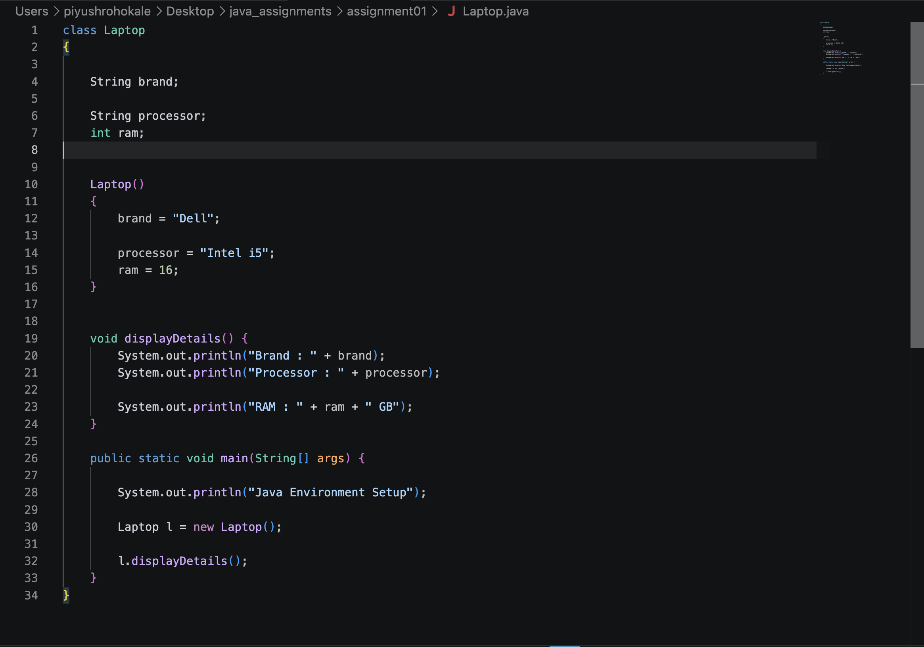
Programme

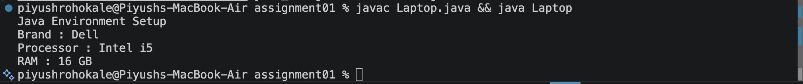
Output
Questions
- Explain the main concept used in Java environment setup, variables and methods.
Ans -> The Java environment consists of three main components:

* JDK (Java Development Kit): A software package used to develop Java applications. It includes the compiler (javac), JRE, and development tools.
* JRE (Java Runtime Environment): Provides the libraries and runtime environment required to execute Java programs.
* JVM (Java Virtual Machine): Executes the compiled Java bytecode and enables Java programs to run on different operating systems, making Java platform-independent.

- What are the advantages of using Java variables and methods?

Ans -> Variables are named memory locations used to store data during program execution. They hold different types of values such as integers, decimal numbers, characters, and strings.

A Method is a block of code that performs a specific task. Methods help organize programs into smaller, reusable units, making the code easier to understand and maintain.

- How can this implementation be improved?

- What are the real-world applications?

Ans -> Java is widely used in various real-world applications due to its platform independence, security, and reliability. Some major applications are:

Android Studio – The official IDE for Android application development.
Minecraft – A popular sandbox video game developed using Java.
Backend Framework: Tech stacks utilize Spring Boot and Hibernate to develop dynamic REST APIs and microservices.

Conclusion
The Java environment (JDK, JRE, and JVM) provides the tools required to develop and execute Java programs. Variables are used to store data, while methods organize the program into reusable blocks, making Java applications efficient, modular, and easy to maintain.

